SUMITTED TO:

**Md. Rashid Al Asif**

Assistant Professor

Department of Computer Science and Engineering

**Shahabuddin Hossain**

**Department:** Economics

**Roll:** 01-052-19

**Batch:** 52

|  |  |
| --- | --- |
| **Remittance and Its Economic Impact in Bangladesh** | Submitted By |

Contents

**Abstract** 2

**Introduction** 3

**Background/Related Work** 3

**System Design** 4

**Results and Discussion** 5

**Insights:** 5

**Conclusion and Future Work** 7

**References** 8

**Remittance and Its Economic Impact in Bangladesh**

# 

# **Abstract**

This report examines the economic impact of remittance in Bangladesh, emphasizing its pivotal role in driving socioeconomic development. Over the years, remittances have emerged as one of the largest sources of foreign exchange for the country, bolstering economic stability and resilience. These financial inflows significantly contribute to poverty alleviation by providing households with resources for better education, healthcare, and investment opportunities, thereby improving overall living standards. Furthermore, remittances play a crucial role in strengthening the nation’s foreign exchange reserves, facilitating the financing of imports and reducing reliance on external borrowing. Despite these advantages, the reliance on remittances presents challenges such as over-dependency on specific labor markets, exploitation of migrant workers, and the lack of skill development among the workforce. Addressing these issues requires well-structured policies and international collaboration to ensure sustainable growth and equitable benefits from remittance inflows.

# **Introduction**

Bangladesh has emerged as one of the top remittance-receiving countries globally. With a substantial portion of its population working abroad, remittance inflows play a critical role in the country's economic growth. This report explores the dynamics of remittance, its contribution to GDP, and the challenges associated with its reliance.

The rise of remittances has transformed many rural economies in Bangladesh. These monetary inflows have created a ripple effect on local markets, increased purchasing power, and improved infrastructure development in underdeveloped regions. However, there remains a need to explore its long-term sustainability and potential risks.

# **Background/Related Work**

The concept of remittance refers to the transfer of money by expatriates to their home country. Numerous studies highlight the positive correlation between remittance inflows and economic stability in developing countries. In Bangladesh, remittances have been instrumental in reducing poverty levels, ensuring financial inclusion, and supporting rural development.

Research has consistently shown that remittance inflows significantly reduce income inequality. Reports from institutions such as the World Bank indicate that households receiving remittances are more likely to invest in education and healthcare. However, challenges such as brain drain, labor exploitation, and dependency on specific labor markets are also evident.

# **System Design**

This section discusses the framework for analyzing the impact of remittance on the Bangladeshi economy. The analysis incorporates:

1. **Data Collection:** Information from sources like Bangladesh Bank, World Bank, and international labor organizations is gathered to build a reliable dataset.

|  |  |  |  |  |  |  |  |  |  |  |  |
| --- | --- | --- | --- | --- | --- | --- | --- | --- | --- | --- | --- |
| | **Month** |  |  | | --- | --- | --- | | |  | **FY23 ($b)** |  | | --- | --- | --- | | |  |  | **FY24 ($b)** | | --- | --- | --- | |
| July | 2.2 | 1.8 |
| August | 1.9 | 1.7 |
| September | 1.6 | 1.4 |
| October | 1.5 | 1.6 |
| November | 1.6 | 1.8 |
| December | 1.7 | 2.0 |
| January | 1.8 | 1.6 |
| February | 1.7 | 1.8 |
| March | 1.8 | 2.0 |

1. **Indicators:** Key performance indicators include GDP contribution, poverty reduction rates, foreign exchange reserves, and household expenditure patterns.
2. **Methodology:** A comparative analysis is conducted using economic models, historical data, and case studies from regions heavily reliant on remittance income.
3. **Economic Models:** Tools such as input-output models and regression analysis are used to understand the macroeconomic impact of remittances.

# **Results and Discussion**

## Results:

1. **Contribution to GDP:** Remittances accounted for approximately 6-8% of Bangladesh's GDP in recent years, demonstrating their critical importance.
2. **Poverty Reduction:** Significant impact on rural poverty alleviation, with many households relying on remittance for education, healthcare, and entrepreneurship.
3. **Foreign Reserves:** These inflows have helped boost foreign exchange reserves, ensuring a stable currency and supporting imports critical for economic growth.

## Discussion:

While remittance brings substantial benefits, it poses challenges such as labor exploitation, lack of skill development, and socio-economic dependency. Labor markets are often concentrated in the Middle East, exposing the workforce to geopolitical and economic risks. Policies promoting diversification in job markets, skill development programs, and stronger labor rights protections are essential to maximize the benefits of remittances.

# **Insights:**

Remittance inflows into Bangladesh increased by 10.66% year-on-year in the just-concluded fiscal year, supported by factors including increased manpower exports and a rising dollar rate.

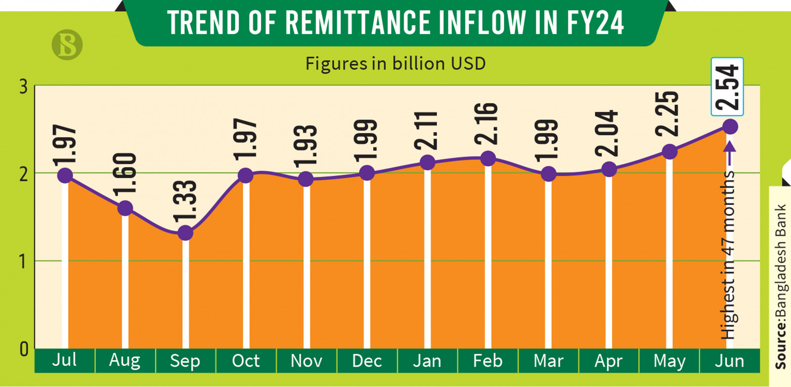

# Remittance inflows to Bangladesh dipped in March 2024 to $1.99 billion, a 1.23% year-on-year decrease, marking the lowest monthly receipts of the year. The drop, unusual ahead of Eid-ul-Fitr, is attributed to higher unofficial dollar exchange rates compared to official channels. Despite concerns, experts remain hopeful of a rebound in inflows as Eid approaches.

# **Conclusion and Future Work**

Remittance remains a cornerstone of Bangladesh's economic stability and growth. It has positively influenced poverty alleviation, household income, and macroeconomic stability. However, addressing the challenges requires targeted government policies and international cooperation. Key recommendations include:

1. Expanding labor markets to countries with higher wage structures.
2. Developing skill enhancement programs to increase competitiveness in global markets.
3. Encouraging productive investment of remittance money in sectors like small businesses and rural enterprises.

Future research could focus on exploring innovative technologies, such as blockchain, to reduce transaction costs and improve transparency in remittance flows. Additionally, analyzing the long-term socio-economic impacts of remittance dependence will provide valuable insights for policymakers.

# **References**

1. World Bank. (2023). *Remittance Trends and Outlook*. Retrieved from <https://worldbank.org>
2. Bangladesh Bank. (2022). *Annual Economic Reports*. Dhaka: Bangladesh Bank.
3. Rahman, M. M. (2021). "Impact of Remittances on Rural Development in Bangladesh," *Journal of Development Studies*, 57(3), 45-60.
4. International Labour Organization. (2020). *Labour Migration in Bangladesh: Opportunities and Challenges*. Geneva: ILO.
5. The Business Standard. (2024). *Remittances grow by 10% in FY24 – the second highest in history.* Retrieved from [https://www.tbsnews.ne](https://www.tbsnews.net)